**1.Create a program that blinks the LED on the development board using MBED software**

**Aim:**

To write a program for blink led using tinker Cad.

**Components Used:**

1.Arduino Uno

2. LED(Light Emitting Diode)

**Procedure:**

1.Get the Arduino uno board from the components

2.Get the LED from the components

3.LED has two side which is positive (anode) and Negative(Cathode).Negative side is connected to the Ground(GND).Positive side is connected to Digital pin 13 of Arduino .

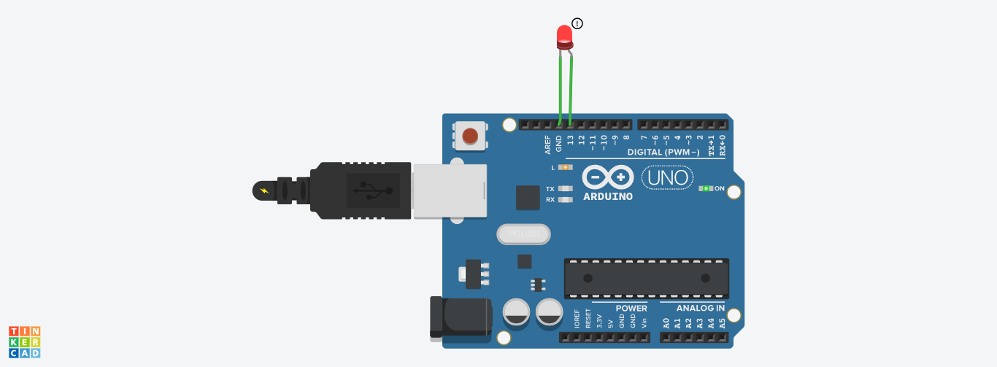

Code:

void setup()

{

pinMode(13, OUTPUT);

}

void loop()

{

digitalWrite(13, HIGH);

delay(1000); // Wait for 1000 millisecond(s)

digitalWrite(13, LOW);

delay(1000); // Wait for 1000 millisecond(s)

}

**1.2.Through Button blink LED**

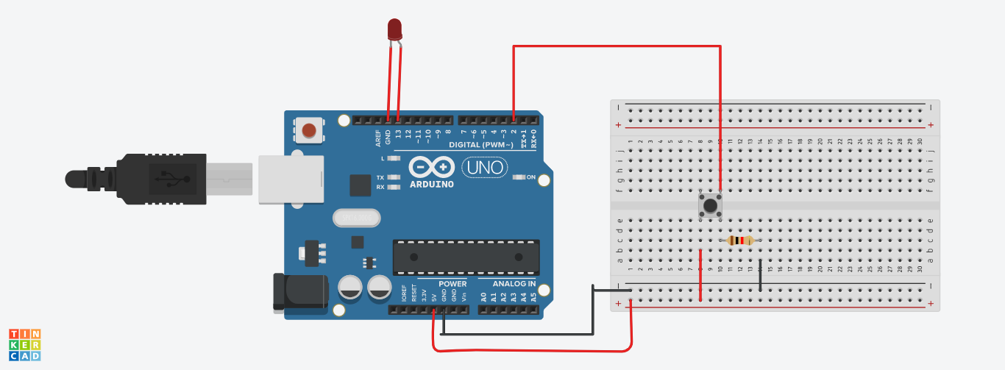

void setup()

{

pinMode(2, INPUT);

pinMode(13,OUTPUT);

}

void loop()

{

if(digitalRead(2)==1)

{

digitalWrite(13,HIGH);

}

else

{

digitalWrite(13,LOW);

}

}

1.3. Led with digital counter

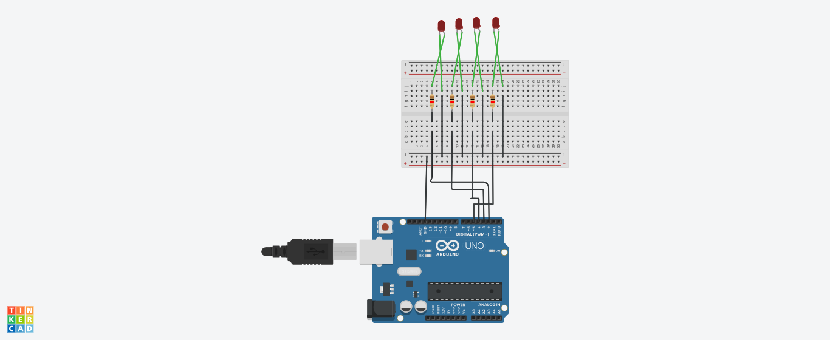

CODE:

int pin2=2;

int pin3=3;

int pin4=4;

int pin5=5;

int stime=500;

void setup()

{

pinMode(pin2,OUTPUT);

pinMode(pin3,OUTPUT);

pinMode(pin4,OUTPUT);

pinMode(pin5,OUTPUT);

}

void loop()

{

digitalWrite(pin2,LOW);

digitalWrite(pin3,LOW);

digitalWrite(pin4,LOW);

digitalWrite(pin5,LOW);

delay(stime);

digitalWrite(pin2,LOW);

digitalWrite(pin3,LOW);

digitalWrite(pin4,LOW);

digitalWrite(pin5,HIGH);

delay(stime);

digitalWrite(pin2,LOW);

digitalWrite(pin3,LOW);

digitalWrite(pin4,HIGH);

digitalWrite(pin5,LOW);

delay(stime);

digitalWrite(pin2,LOW);

digitalWrite(pin3,LOW);

digitalWrite(pin4,HIGH);

digitalWrite(pin5,HIGH);

delay(stime);

digitalWrite(pin2,LOW);

digitalWrite(pin3,HIGH);

digitalWrite(pin4,LOW);

digitalWrite(pin5,LOW);

delay(stime);

digitalWrite(pin2,LOW);

digitalWrite(pin3,HIGH);

digitalWrite(pin4,LOW);

digitalWrite(pin5,HIGH);

delay(stime);

digitalWrite(pin2,LOW);

digitalWrite(pin3,HIGH);

digitalWrite(pin4,HIGH);

digitalWrite(pin5,LOW);

delay(stime);

digitalWrite(pin2,LOW);

digitalWrite(pin3,HIGH);

digitalWrite(pin4,HIGH);

digitalWrite(pin5,HIGH);

delay(stime);

digitalWrite(pin2,HIGH);

digitalWrite(pin3,LOW);

digitalWrite(pin4,LOW);

digitalWrite(pin5,LOW);

delay(stime);

digitalWrite(pin2,HIGH);

digitalWrite(pin3,LOW);

digitalWrite(pin4,LOW);

digitalWrite(pin5,HIGH);

delay(stime);

digitalWrite(pin2,HIGH);

digitalWrite(pin3,LOW);

digitalWrite(pin4,HIGH);

digitalWrite(pin5,LOW);

delay(stime);

digitalWrite(pin2,HIGH);

digitalWrite(pin3,LOW);

digitalWrite(pin4,HIGH);

digitalWrite(pin5,HIGH);

delay(stime);

digitalWrite(pin2,HIGH);

digitalWrite(pin3,HIGH);

digitalWrite(pin4,LOW);

digitalWrite(pin5,LOW);

delay(stime);

digitalWrite(pin2,HIGH);

digitalWrite(pin3,HIGH);

digitalWrite(pin4,LOW);

digitalWrite(pin5,HIGH);

delay(stime);

digitalWrite(pin2,HIGH);

digitalWrite(pin3,HIGH);

digitalWrite(pin4,HIGH);

digitalWrite(pin5,LOW);

delay(stime);

digitalWrite(pin2,HIGH);

digitalWrite(pin3,HIGH);

digitalWrite(pin4,HIGH);

digitalWrite(pin5,HIGH);

delay(stime);

}

4.Pick one-one from the available sensors and actuators and find or create code that will display the sensed data on the PC.

Actutors:

Convert the electrical signal into light energy.

Capacitors-100 ohm

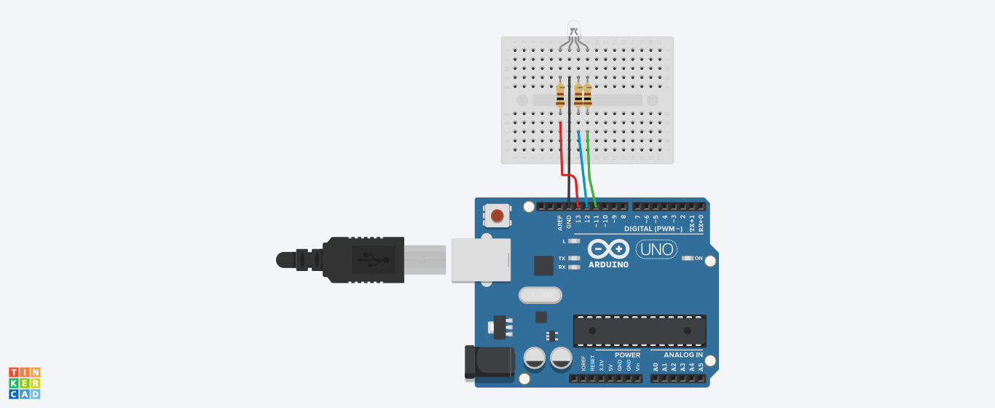

Code:

int redled=13;

int blueled=12;

int greenled=11;

void setup()

{

pinMode(redled, OUTPUT);

pinMode(blueled,OUTPUT);

pinMode(greenled,OUTPUT);

Serial.begin(9600);

Serial.println("rgb");

}

void loop()

{

digitalWrite(redled, HIGH);

digitalWrite(blueled,HIGH);

digitalWrite(greenled,HIGH);

delay(1000); // Wait for 1000 millisecond(s)

// Wait for 1000 millisecond(s)

}

Reading numbers from te serial monitor-toto18